16) Write a C program to implement hashing using Linear Probing method

PROGRAM:

#include <stdio.h>

#define SIZE 10

int hash(int key) {

return key % SIZE;

}

int probe(int H[], int key) {

int index = hash(key);

int i = 0;

while (H[(index + i) % SIZE] != 0)

i++;

return (index + i) % SIZE;

}

void insert(int H[], int key) {

int index = hash(key);

if (H[index] != 0)

index = probe(H, key);

H[index] = key;

}

void display(int H[]) {

for (int i = 0; i < SIZE; i++)

printf("%d ", H[i]);

}

int main() {

int HT[SIZE] = {0};

insert(HT, 12);

insert(HT, 25);

insert(HT, 35);

insert(HT, 26);

display(HT);

return 0;

}

INPUT:

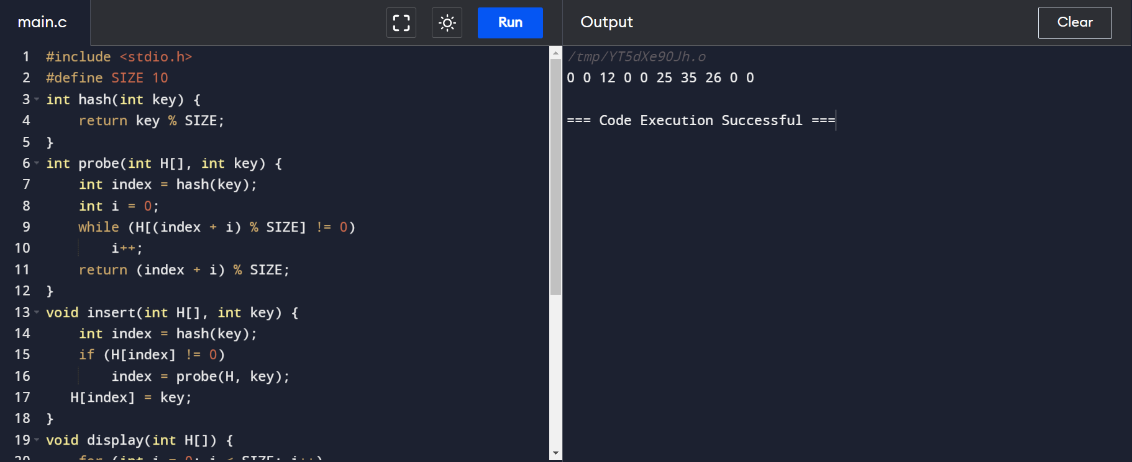

OUTPUT:

